CLOUDDEPLOYMENT SERVICES

Here is a simple table for deployment alternatives from Amazon Web Services (AWS), Azure - Microsoft's Cloud Computing Platform, and Google Cloud.  
  
🔹 Infrastructure as a Service (IaaS)  
You got VMs, do as you please.  
  
- AWS: EC2  
- Azure: Virtual Machines  
- GCP: Compute Engine  
  
🔹 Container as a Service (CaaS)  
You can think of containers as lightweight VMs packaging app runtime. Configure a VM cluster to orchestrate containers (typically with Kubernetes).  
  
- AWS: Elastic Container Service (ECS) or Elastic Kubernetes Service (EKS) with EC2  
- Azure: Azure Kubernetes Service (AKS)  
- GCP: Kubernetes Engine  
  
🔹 Serverless CaaS  
All benefits of containers but without the hassle of managing the Kubernetes cluster.  
  
- AWS: App Runner. ECS or EKS with Fargate  
- Azure: Container Apps  
- GCP: Cloud Run  
  
🔹 Platform as a Service (PaaS)  
Canned app runtimes provided by cloud vendors along with auto-scale. I foresee Serverless CaaS overshadowing PaaS. I mean, why limit yourself to the runtime canned by vendors when you can pick your own with a container?  
  
- AWS: Elastic Beanstalk  
- Azure: App Service  
- GCP: App Engine  
  
🔹 Function as a Service (FaaS)  
Design your application and services as event-driven, stateless, short-lived "nano" services.  
  
- AWS: Lambda  
- Azure: Function  
- GCP: Cloud Function  
  
Check out the resources in the first comment.  
  
👉 For more content on Machine Learning for Developers, subscribe to #ML4Devs newsletter.  
  
#BigData #DataEngineering #DataAnalytics #DataScience #MachineLearning #MLOps #CloudComputing #Microservices #Cloud #AWS #Azure #GCP #GoogleCloud

[[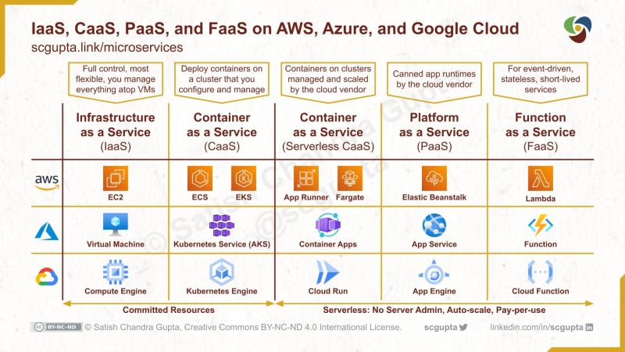](https://www.linkedin.com/search/results/content/?keywords=ELASTIC%20CONTAINER%20SERVICE&update=urn%3Ali%3Afs_updateV2%3A%28urn%3Ali%3Aactivity%3A6957563974309556224%2CBLENDED_SEARCH_FEED%2CEMPTY%2CDEFAULT%2Cfalse%29)](https://www.linkedin.com/search/results/content/?keywords=ELASTIC%20CONTAINER%20SERVICE&update=urn%3Ali%3Afs_updateV2%3A%28urn%3Ali%3Aactivity%3A6957563974309556224%2CBLENDED_SEARCH_FEED%2CEMPTY%2CDEFAULT%2Cfalse%29)